**US Drone Strike Kills 9 Pakistani Militants in Afghanistan**

**US Drone Strike Kills 9 Pakistani Militants in Afghanistan**

[World](http://www.ndtv.com/world-news) | [Agence France-Presse](http://www.ndtv.com/topic/agence-france-presse) | Updated: March 24, 2015 21:56 IST

**EMAIL**

**PRINT**

**COMMENTS**

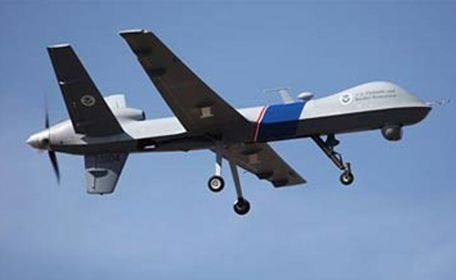

File photo of an unmanned US drone. (Associated Press)

**Peshawar, Pakistan:** A US drone strike in eastern Afghanistan has killed nine militants linked to the Pakistani Taliban in an area close to the countries' rugged border, officials said today.  
  
The strike came in the Nasyan area of the eastern Afghan province of Nangarhar, close to the border with the Pakistani tribal district of Khyber.  
  
Pakistani security officials said the militants belonged to the Lashkar-e-Islam, Tehreek-e-Taliban Pakistan (TTP) and Abdullah Azam Brigade militant groups.  
  
A NATO spokesman in Kabul confirmed the strike and said it was carried out on Monday, but gave no details on the number of causalities.

"We can confirm there was a US precision strike during an operation in Nasyan district, Nangarhar province, 23 March," the spokesman said.  
  
The strike is the latest evidence of increasing cooperation between the two neighbours and US-led forces in combating TTP militants who have fled across the border from a Pakistani military operation.  
  
After years of fractious ties and mistrust, Kabul and Islamabad are improving relations under new Afghan President Ashraf Ghani and both countries have agreed to take action against militants using their territory to launch attacks.  
  
Pakistan's army chief visited Kabul after a deadly Taliban attack on a school in the northwestern Pakistani city of Peshawar in December that killed 154 people, mostly schoolchildren.  
  
Last Thursday, the Pakistani Taliban said a US drone strike in eastern Afghanistan killed a senior commander who was a close associate of two of the group's former chiefs.  
  
The strike comes at a time when President Barack Obama is to meet with Ghani, who has asked Washington for "flexibility" on the pace of US troop withdrawals from the war-torn country.  
  
With the end of the US-led NATO combat mission in 2014, Afghan forces have taken over responsibility for security across the nation, still wrestling with a resilient Taliban insurgency.  
  
In a stark reminder of the violence still racking Afghanistan, gunmen killed 13 bus passengers in a province close to Kabul early today.

**Story First Published:** March 24, 2015 16:59 IST